Ancient body clock discovered that helps to keep all living things on time

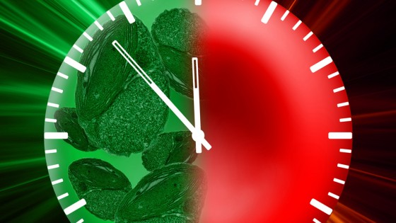

The mechanism that controls the internal 24-hour clock of all forms of life from human cells to algae has been identified by scientists.

Not only does the research provide important insight into health-related problems linked to individuals with disrupted clocks – such as pilots and shift workers – it also indicates that the 24-hour circadian clock found in human cells is the same as that found in algae and dates back millions of years to early life on Earth.

Two new studies out tomorrow, 27 January, in the journal Nature from the Universities of Cambridge and Edinburgh give insight into the circadian clock which controls patterns of daily and seasonal activity, from sleep cycles to butterfly migrations.

One study, from the Institute of Metabolic Science at the University of Cambridge, has for the first time identified 24-hour rhythms in red blood cells.

This is significant because circadian rhythms have always been assumed to be linked to DNA and gene activity, but – unlike most of the other cells in the body – red blood cells do not have DNA.

Akhilesh Reddy, from the University of Cambridge and lead author of the study, said: “We know that clocks exist in all our cells; they’re hard-wired into the cell.

Imagine what we’d be like without a clock to guide us through our days.

The cell would be in the same position if it didn’t have a clock to coordinate its daily activities.

“The implications of this for health are manifold. We already know that disrupted clocks – for example, caused by shift-work and jet-lag – are associated with metabolic disorders such as diabetes, mental health problems and even cancer.

By furthering our knowledge of how the 24-hour clock in cells works, we hope that the links to these disorders – and others – will be made clearer.

This will, in the longer term, lead to new therapies that we couldn’t even have thought about a couple of years ago.”

For the study, the scientists, funded by the Wellcome Trust, incubated purified red blood cells from healthy volunteers in the dark and at body temperature, and sampled them at regular intervals for several days.

They then examined the levels of biochemical markers – proteins called peroxiredoxins – that are produced in high levels in blood and found that they underwent a 24-hour cycle. Peroxiredoxins are found in virtually all known organisms.

A further study, by scientists working together at the Universities of Edinburgh and Cambridge, and the Observatoire Oceanologique in Banyuls, France, found a similar 24-hour cycle in marine algae, indicating that internal body clocks have always been important, even for ancient forms of life.

The researchers in this study found the rhythms by sampling the peroxiredoxins in algae at regular intervals over several days.

When the algae were kept in darkness, their DNA was no longer active, but the algae kept their circadian clocks ticking without active genes.

Scientists had thought that the circadian clock was driven by gene activity, but both the algae and the red blood cells kept time without it.

Andrew Millar of the University of Edinburgh’s School of Biological Sciences, who led the study, said: “This groundbreaking research shows that body clocks are ancient mechanisms that have stayed with us through a billion years of evolution.

They must be far more important and sophisticated than we previously realised.

More work is needed to determine how and why these clocks developed in people – and most likely all other living things on earth – and what role they play in controlling our bodies.”

Additional funding for the studies was provided by the Biotechnology and Biological Sciences Research Council, the Engineering and Physical Sciences Research Council, the Medical Research Council, the French Agence Nationale de la Recherche, and the National Institute of Health Research.